Group #3

Participants: Ivan Pryymak, John Sullivan, Yohannes Ayele, Nilam Abdul-Haqq

Project: Outland Adventures

Report #1: Aged Inventory Items

This report shows all equipment that is at least 5 years old.

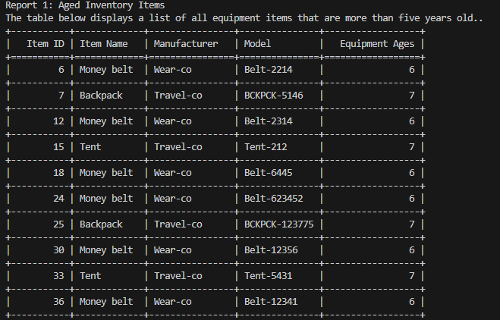

Report #2: Booking Trends

This report shows how many trips was booked for each region (Africa, Asia, Southern Europe) by year.

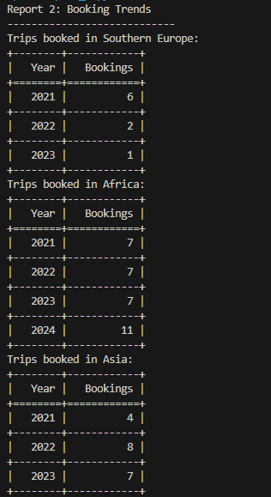

Report #3: Equipment Sales

This report shows the total number of times the equipment was rented and number of times it was purchased.

